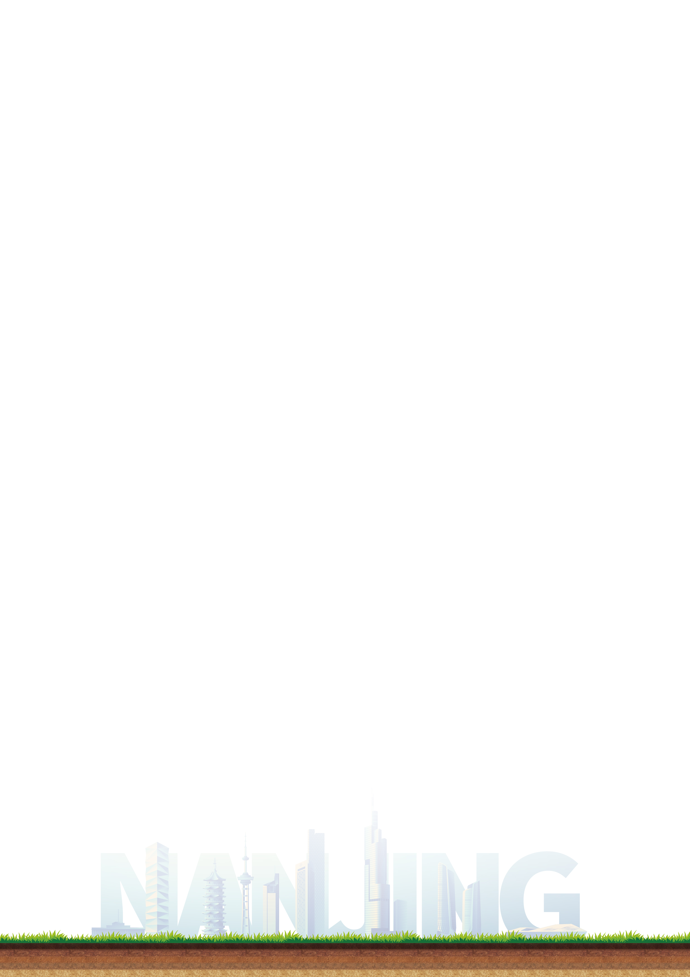
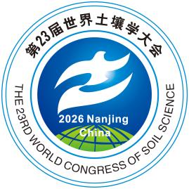
The 23rd World Congress
of Soil Science
Nanjing, China|7-12 June 2026
CERTIFICATE OF ATTENDANCE
This is to certifies that

[NAME]
of
[AFFILIATION]
attended the 23rd World Congress of Soil Science, held at Nanjing International Expo Centre, Nanjing, China, from 7 to 12 June 2026.

Issued in Nanjing, China, on the 12th of June 2026.

Prof. Jiabao Zhang
Chair of WCSS2026 Organizing Committee
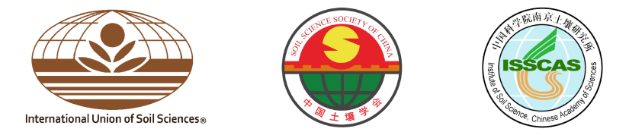
President of the Soil Science Society of China

