The Cultural Experience to Qinhuai River Scenic Area
I. Date
Jun.10, 2026
II. Location
Nanjing, China
IV. Schedule
P3 Parking Lot, Nanjing International Expo Convention Center→ Qinhuai River Scenic Area → P3 Parking Lot, Nanjing International Expo Convention Center
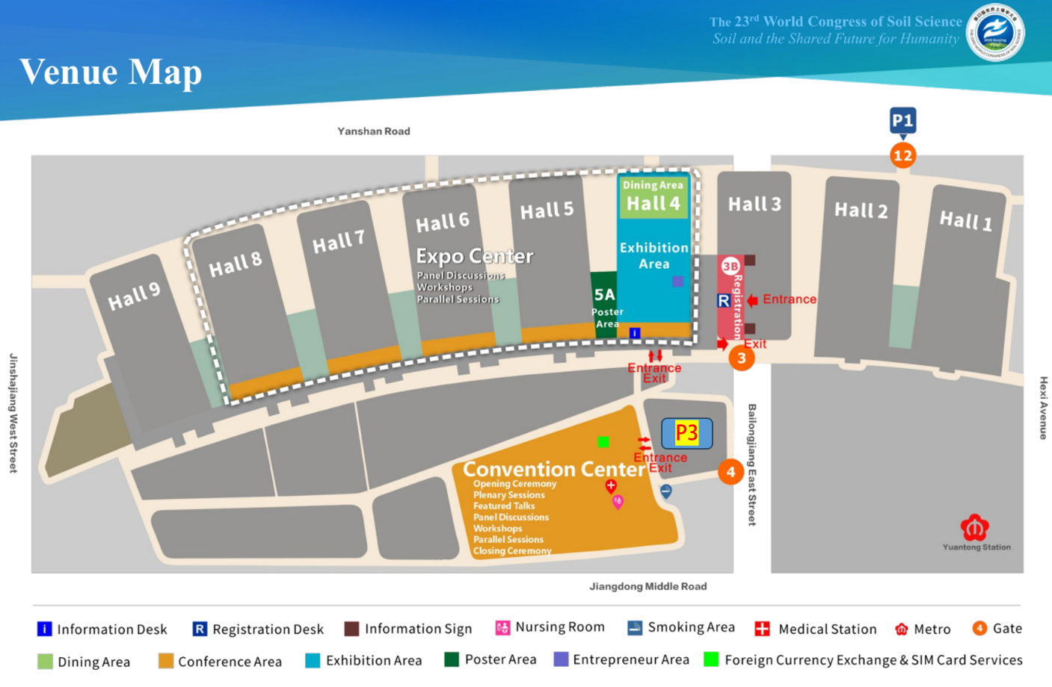
IV. Schedule
11:00 Meet at P3 Parking Lot, Nanjing International Expo Convention Center for coach departure.
11:30–12:00 Light lunch (sandwiches & drinks) on board coach; depart for Nanjing City Wall Museum
12:00–13:00 Visit Nanjing City Wall Museum
13:00–13:40 Explore the Barbican of Zhonghua Gate
13:50–15:00 Sightseeing at Laomen East Historic District
15:00–15:50 Boat cruise along the Qinhuai River on traditional painted pleasure boats
16:00–17:00 Tour the Qinhuai River Scenic Belt
17:00–18:00 Return by coach

V. Pricing
USD 60 per participant, including round-trip transportation, bilingual escort and lunch.

The Cultural Experience to Huanglongxian Tea Village
I. Date
Jun.10, 2026
II. Location
Nanjing, China
III. Itinerary
P3 Parking Lot, Nanjing International Expo Convention Center → Huanglongxian Tea Culture Village → P3 Parking Lot, Nanjing International Expo Convention Center
IV. Schedule
11:00 Meet at P3 Parking Lot, Nanjing International Expo Convention Center for coach departure.
11:30–12:30 Light lunch (sandwiches and beverages) on board coach; depart for Huanglongxian Tea Village
12:30–14:00 Field observation of tea garden soil profiles & guided tour of tea plantations
14:00–15:30 Tea culture experience plus intangible cultural heritage activities of Nanjing folk customs
15:30–16:30 Free leisure time for self-guided sightseeing in the village
17:00–18:00 Return by coach

V. Pricing
USD 60 per participant, including round-trip transportation, bilingual escort and lunch.

Ecological Study Tour: Jiangsu Academy of Agricultural Science
I. Date
June 10, 2026
II. Location
Nanjing, China
III. Itinerary
P3 Parking Lot, Nanjing International Expo Convention Center → Luhe Experimental Station, JAAS → Main Campus, JAAS → P3 Parking Lot, Nanjing International Expo Convention Center
IV. Schedule
09:00 Meet at P3 Parking Lot, Nanjing International Expo Convention Center for coach departure.
10:00 Arrive at Luhe Experimental Station, JAAS
10:00–12:30 Tour of the Luhe National Agricultural Experimental Station for Agricultural Environment, Ministry of Agriculture and Rural Affairs, P.R. China.
- Stop 1: Long-Term Experimental Site for Monitoring and Regulation of Soil Quality Change
- Stop 2: Experimental Base for Agricultural Waste Recycling Utilization
- Stop 3: Long-Term Observational Experiment on Soil Quality and Environmental Change in Protected Agriculture
- Stop 4: Long-Term Experiment on Soil Carbon Sequestration under Different Straw Return Practices
12:30–13:00 Light lunch (sandwiches and beverages) at the office building, Luhe Experimental Base, JAAS.
13:00–14:00 Assemble and proceed to next destination
14:00–15:00 Guided tour of the Institute of Agricultural Resources and Environment, JAAS.
15:00–17:00 Campus tour of JAAS.
17:00 Return by coach

V. Pricing
USD 70 per participant, including round-trip transportation, bilingual escort and lunch.

Eco-Study Tour: Institute of Soil Science, Chinese Academy of Sciences & Jiangsu Agricultural Expo Park
I. Date
June 10, 2026
II. Location
Nanjing, China
III. Itinerary
P3 Parking Lot, Nanjing International Expo Convention Center → Institute of Soil Science, CAS → Jiangsu Agricultural Expo Park → P3 Parking Lot, Nanjing International Expo Convention Center
IV. Schedule
09:00 Meet at P3 Parking Lot, Nanjing International Expo Convention Center for coach departure.
10:00 Arrival at Nanjing Institute of Soil Science, CAS
10:00–12:00 Tour of the Institute (Institute History Museum + Soil Museum)
12:00 Assemble and proceed to next destination
12:30–13:00 Light lunch (sandwiches and beverages) on board coach; depart for Jiangsu Agricultural Expo Park
13:00–14:00 Visit kiwi fruit and grape greenhouses
14:00–15:00 Tour outdoor planting zones of the Agricultural Expo Park (Chinese herbal garden, Hundred-Flower Stream, Ecological Boulevard)
15:00–17:00 Visit indoor greenhouses in the park (Plant Science & Technology Hall, Popular Science Hall for Plants, Air Plant Pavilion, Strawberry Planting Base, Vegetable Base)
17:00–18:30 Return by coach

V. Pricing
USD 70 per participant, including round-trip transportation, bilingual escort, admission tickets, and lunch.

The Ecological Study Tour to Soil Carbon Neutrality and Climate Change Response Experimental Platform & Xuanwu Lake
I. Date
Jun.10, 2026
II. Location
Nanjing, China
III. Itinerary
P3 Parking Lot, Nanjing International Expo Convention Center → Soil Carbon Neutrality and Climate Change Response Experimental Platform (previously referred to as “Temperature by Free-Air CO₂ Enrichment (T-FACE)”) → Xuanwu Lake → P3 Parking Lot, Nanjing International Expo Convention Center
IV. Schedule
11:00 Meet at P3 Parking Lot, Nanjing International Expo Convention Center for coach departure.
11:30–12:00 Light lunch (sandwiches and beverages) on board coach; depart for the Soil Carbon Neutrality and Climate Change Response Experimental Platform
12:00–14:00 Visit the Soil Carbon Neutrality and Climate Change Response Experimental Platform
14:00–15:00 Depart for Jiming Temple by coach
15:00–15:40 Sightseeing at Jiming Temple
16:00–16:50 Tour Xuanwu Lake
17:00–19:00 Free time for leisure at Jinling Style Block
19:00–20:00 Return by coach

V. Pricing
USD 60 per participant, including round-trip transportation, bilingual escort, admission tickets, and lunch.

The Ecological Study Tour to Soil Profile Study & Zijin Mountain

I. Date
Jun.10, 2026
II. Location
Nanjing, China
III. Itinerary
P3 Parking Lot, Nanjing International Expo Convention Center → Soil Profile Study → Zijin Mountain → P3 Parking Lot, Nanjing International Expo Convention Center
IV. Schedule
9:00 Meet at P3 Parking Lot, Nanjing International Expo Convention Center for coach departure.
09:00–10:00 Depart for soil profile site in Tangshan, Jiangning
10:00–12:00 Field study on soil profiles
12:00–12:30 Light lunch (sandwiches and beverages) on board coach
12:30–13:10 Coach transfer to Xiamafang
13:10–13:30 Start sightseeing at Xiamafang; walk on foot to the Ming Xiaoling Museum
13:30–14:00 Visit Ming Xiaoling Museum
14:10–16:30 Tour Ming Xiaoling Mausoleum (Entry from Great Golden Gate → Stele Pavilion → Stone Animal Sculptures → Stone Warrior Statues → Golden Water Bridge → Hall of Offerings → Precious Citadel; exit via Golden Water Bridge & Stone Warrior Statues and board coach at Gate No.1 of Ming Xiaoling)
16:30–17:30 Return by coach

V. Pricing
USD 80 per participant, including round-trip transportation, bilingual escort, admission tickets, and lunch.

