Connecting Through Soil, Advancing Through Contest

The 5th International Soil Judging Contest Concludes Successfully!
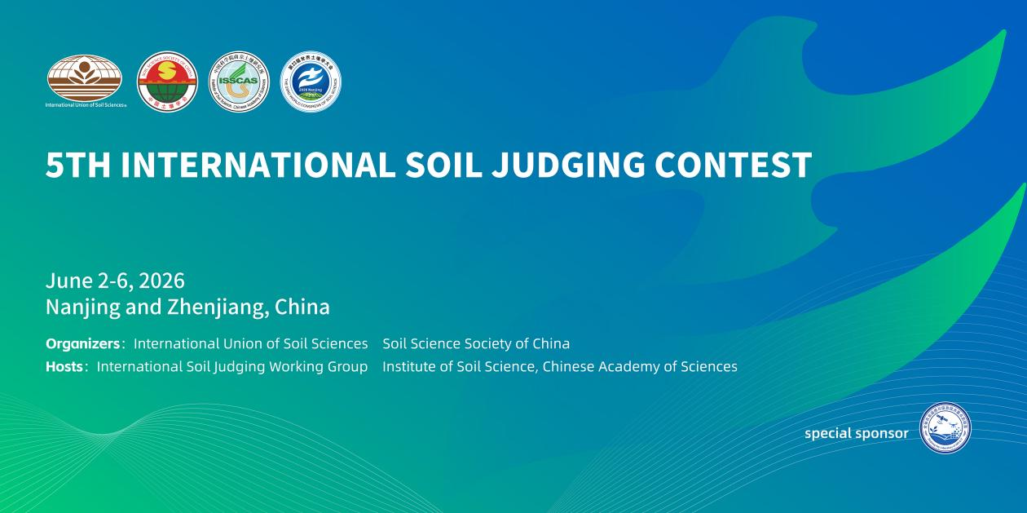On June 7, 2026, the fifth edition of the International Soil Judging Contest came to a successful close in Nanjing, China. Organized by the International Union of Soil Sciences (IUSS) and the Soil Science Society of China, the competition brought together 18 teams from 14 countries to compete in the Nanjing and Zhenjiang competition zones. Through a comprehensive process including pre-event preparation, systematic training, mock exercises, and official contests, all sessions were smoothly conducted, culminating in a grand awards ceremony.

Since the competition was launched two years ago, the organizing committee convened multiple preparatory meetings, organized extensive field reconnaissance and soil profile selection with domestic and international experts, and rigorously refined the technical framework, laying a solid foundation for the successful execution of the event.
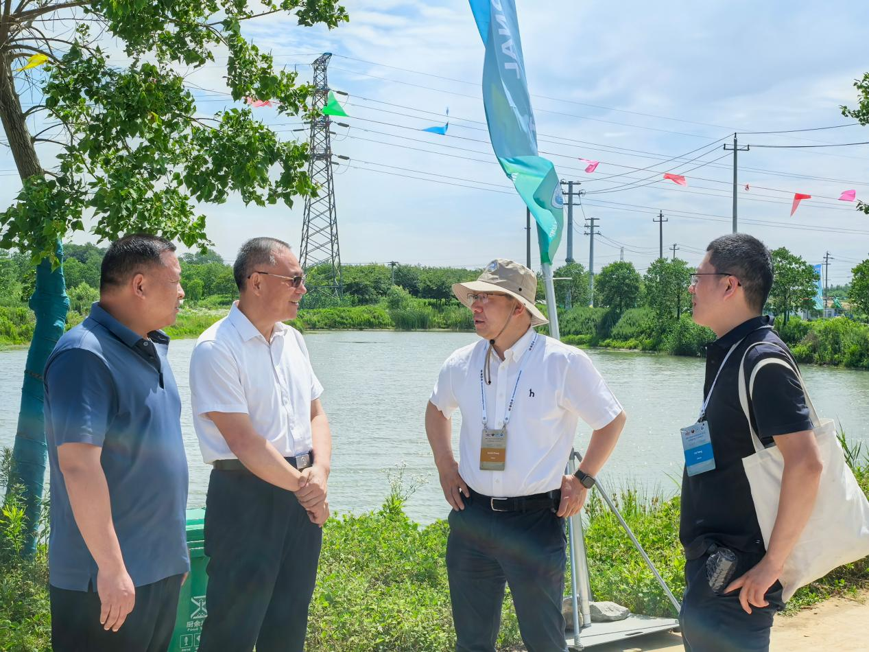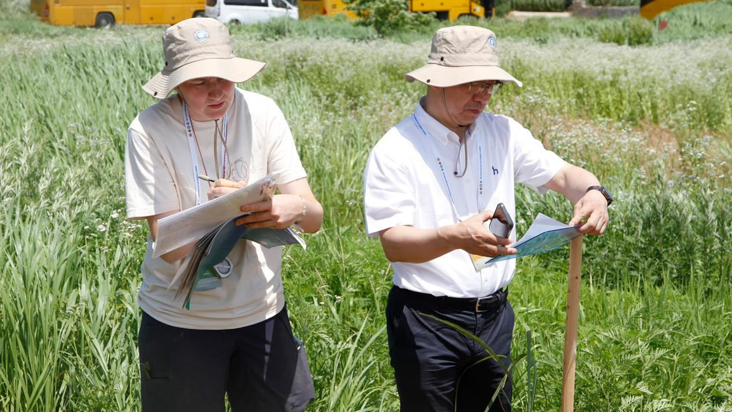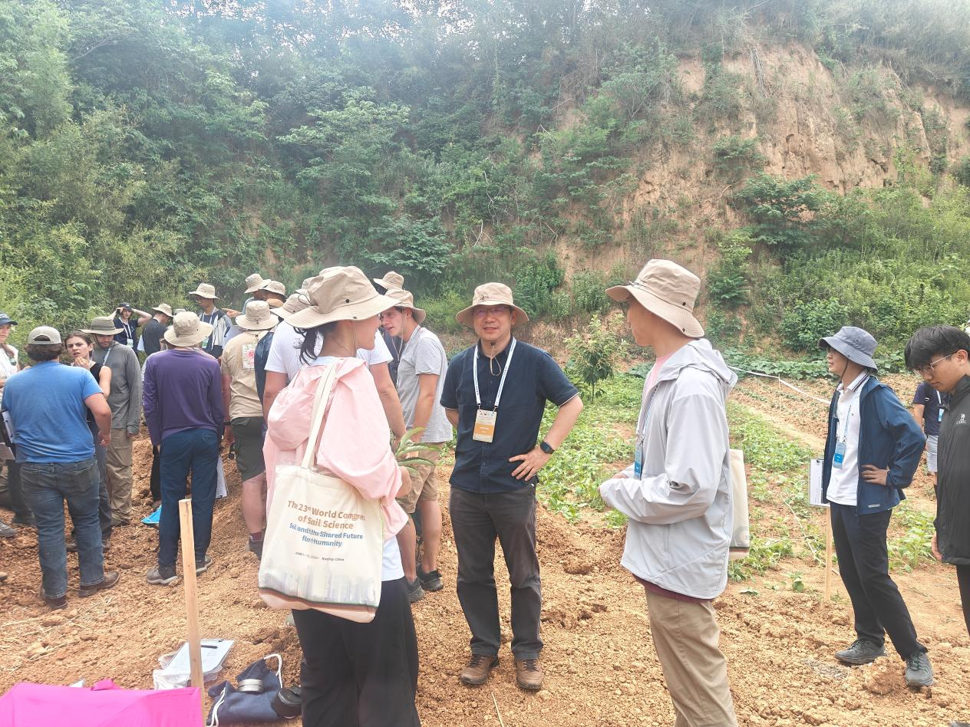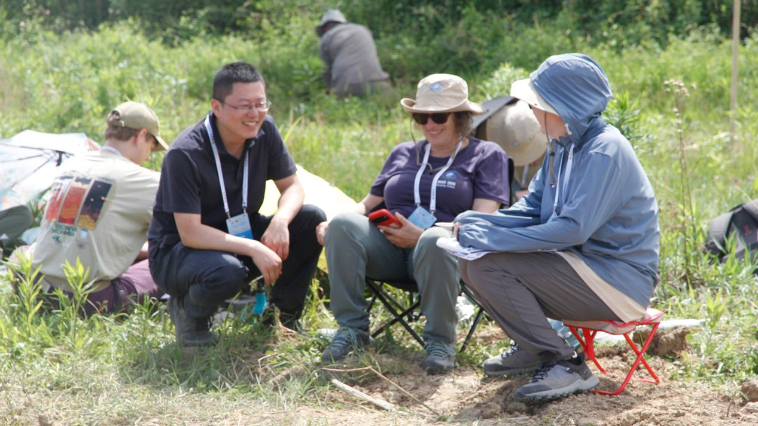
The six-day event began with early preparations: international specialists and volunteers arrived in advance to complete soil profile preparation, competition documentation, and venue setup. On June 2, participating teams from various countries arrived and completed registration, followed by a welcoming banquet. From June 3 to 5, a systematic intensive training phase was conducted. Leveraging the platform of the Institute of Soil Science, Chinese Academy of Sciences, a series of thematic academic lectures were delivered by renowned soil scientists. Topics covered global advances in soil judging, regional soil-forming environments, and physical-chemical characterization of soils. After the lectures, participants were divided into groups and traveled to field training sites in Nanjing and Zhenjiang for hands-on practice in soil texture, color determination, and other essential skills. A contest simulation further sharpened their practical capabilities.
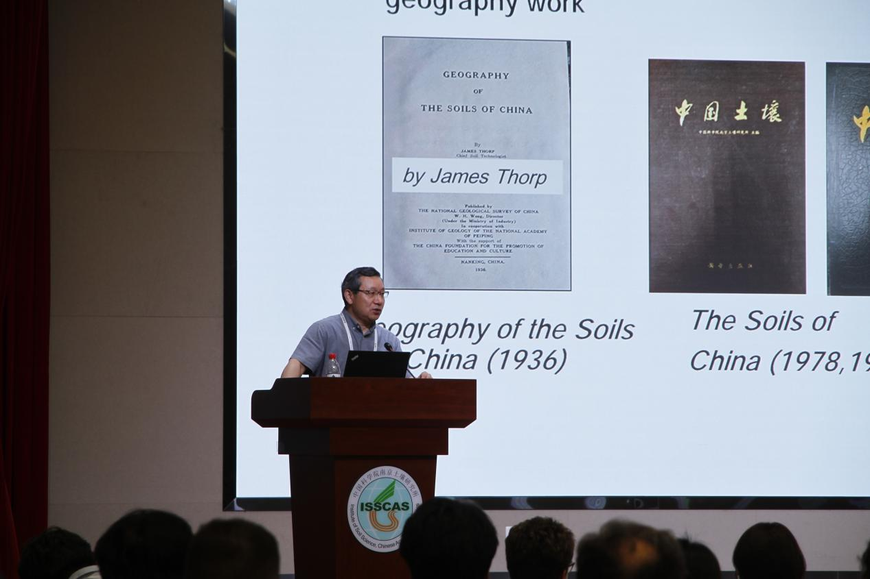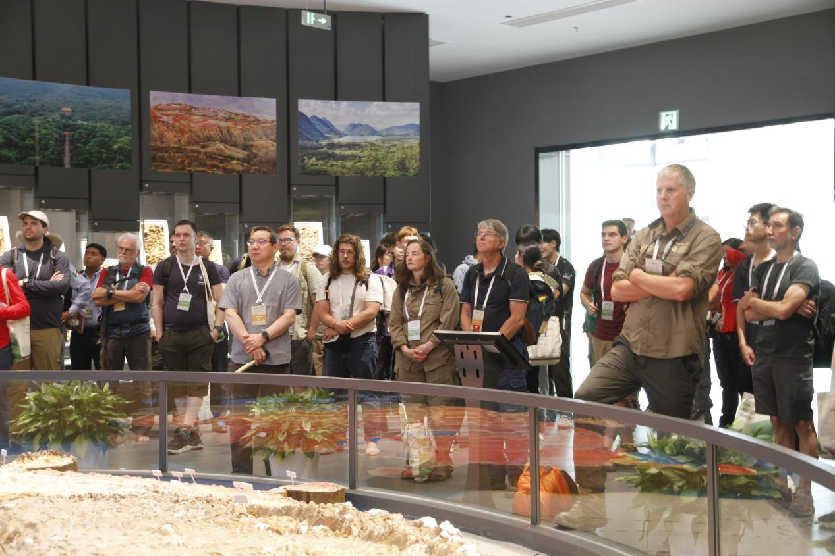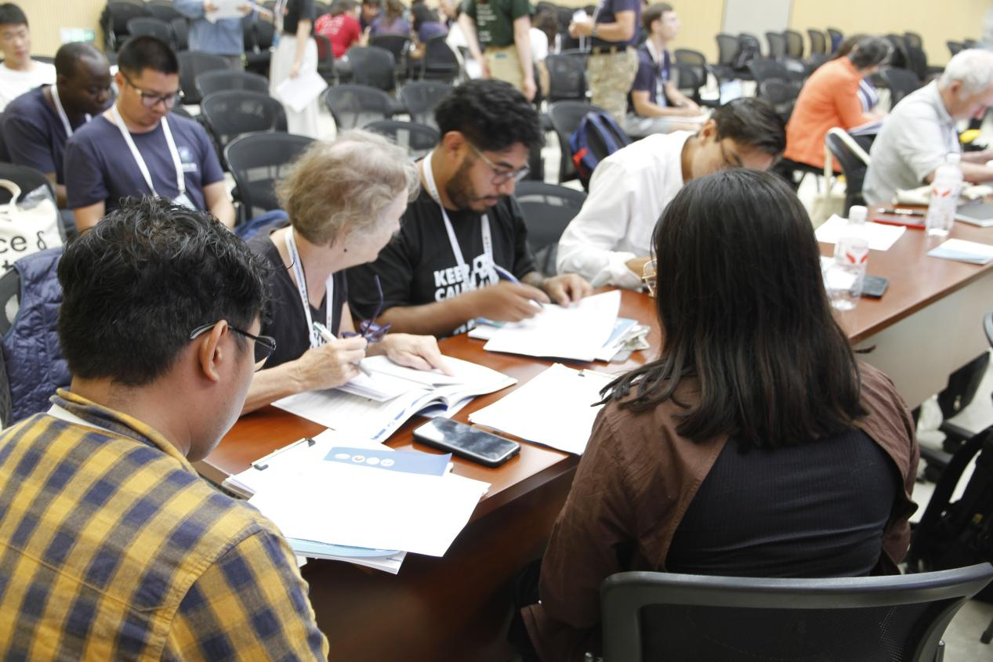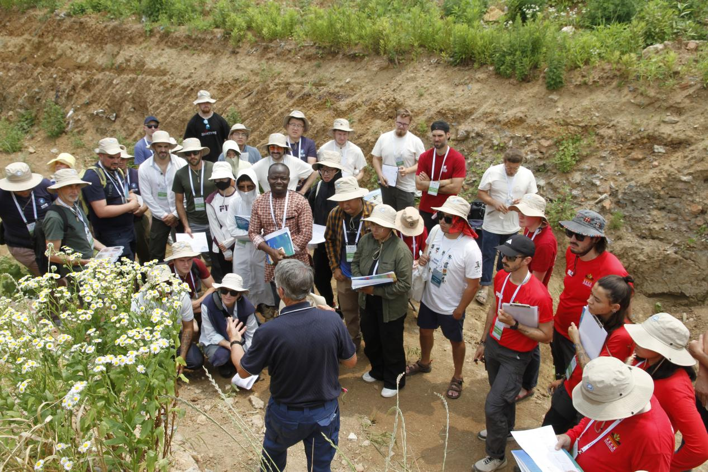(Photo gallery:on-site scenes)

On June 6, the official contest commenced, consisting of both individual and group contests. Based on designated field soil pits, contestants performed on-site profile observation, taxonomic classification, and indicator interpretation. After the contest, the judging panel conducted joint scoring.
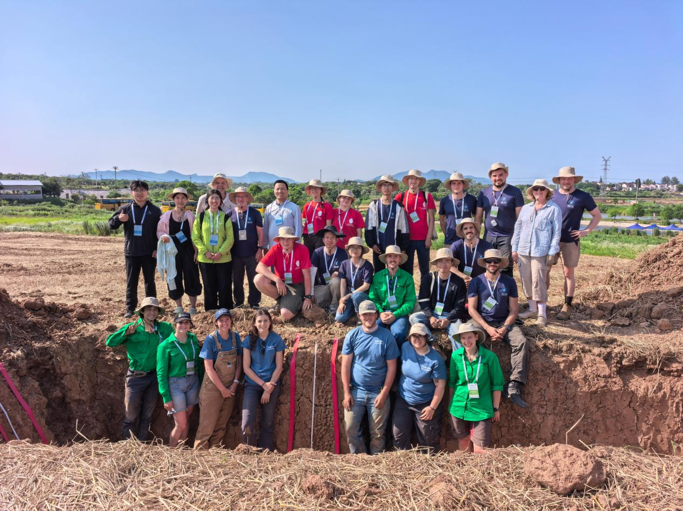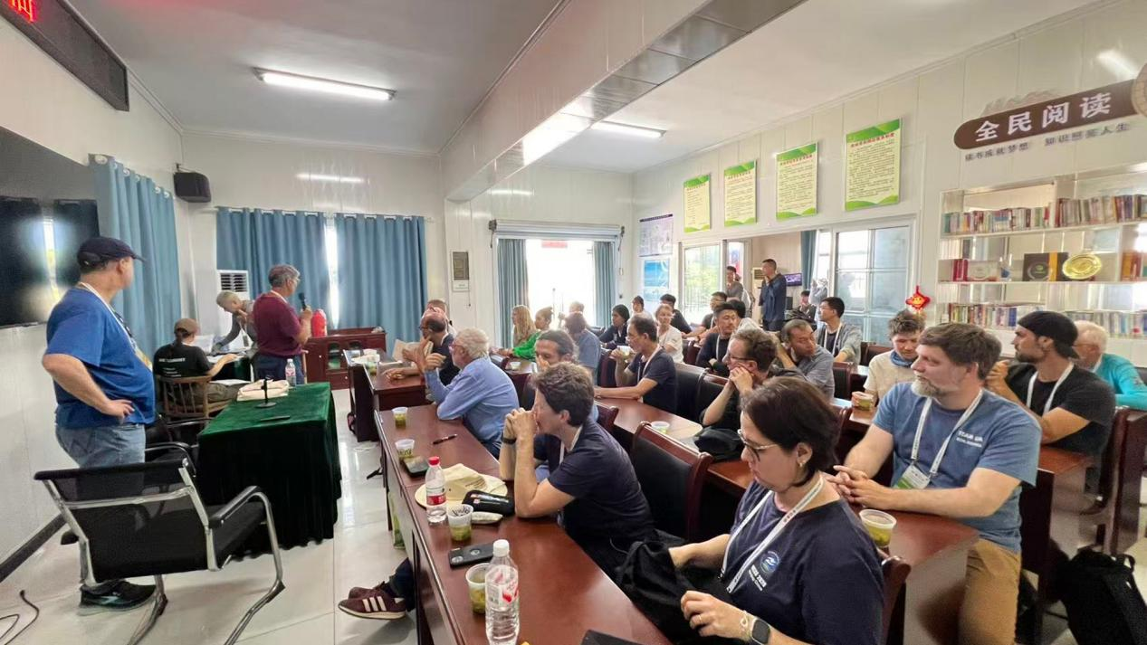
(Photo gallery:on-site scenes)

On June 7, from 16:00 to 19:00, the awards ceremony was held during a cold buffet reception. The organizing committee officially announced the winners of the 5th International Soil Judging Competition:
（The award list will be presented in tabular format.）
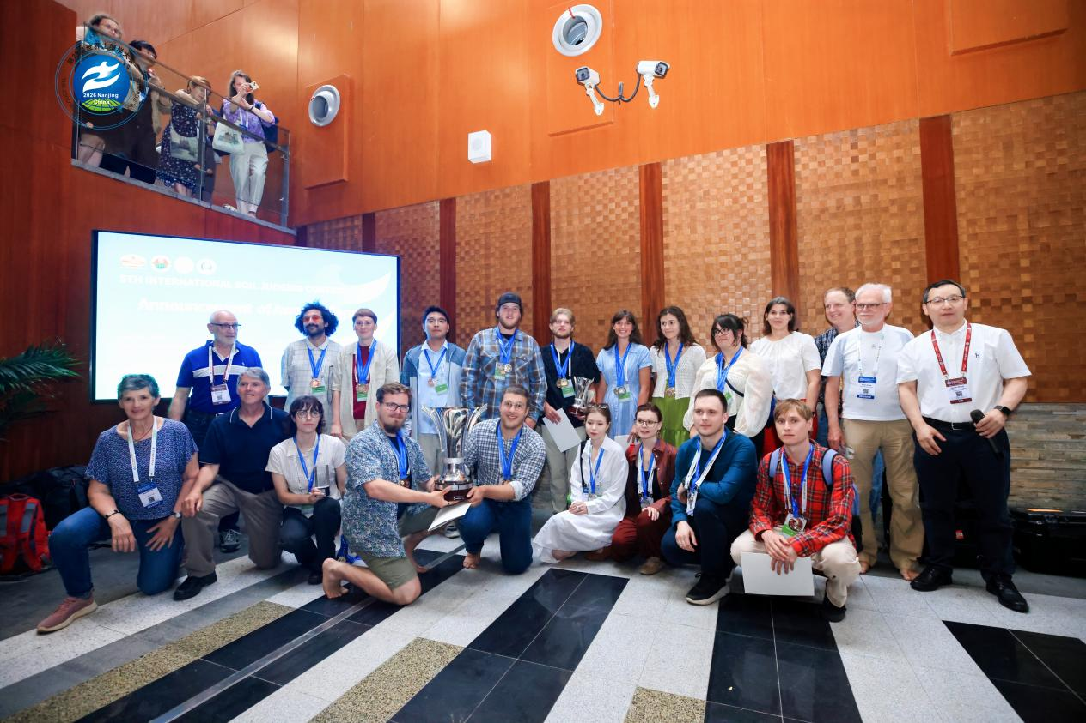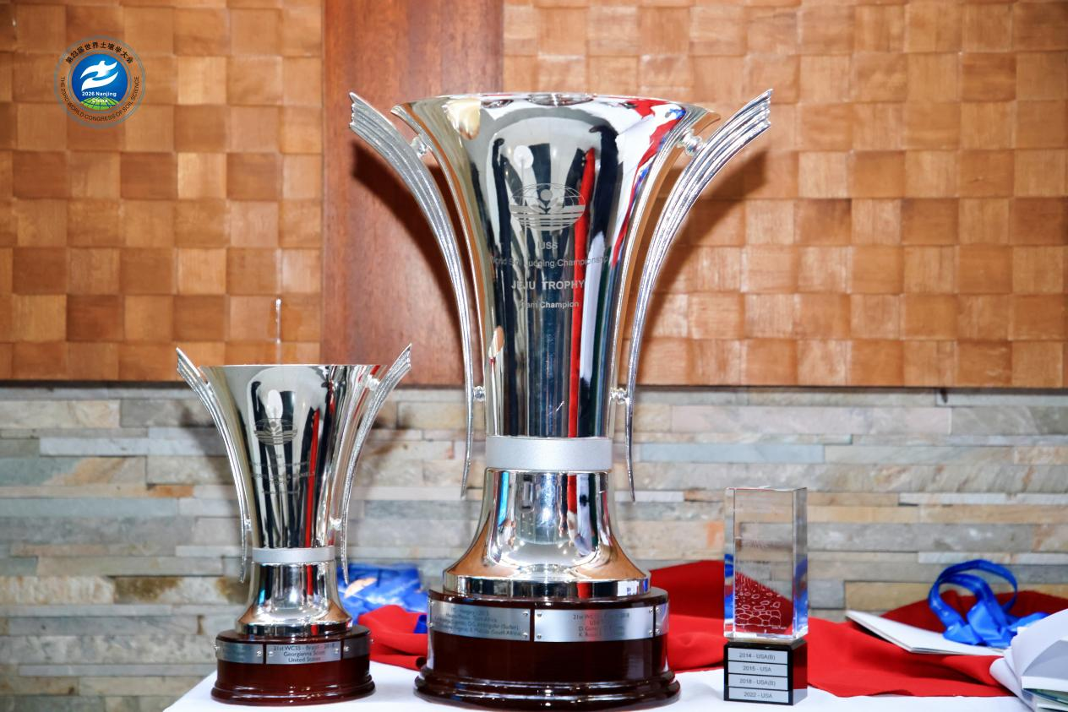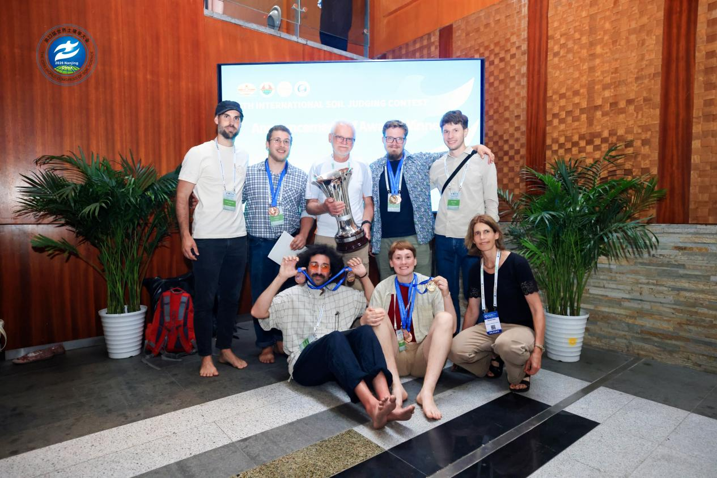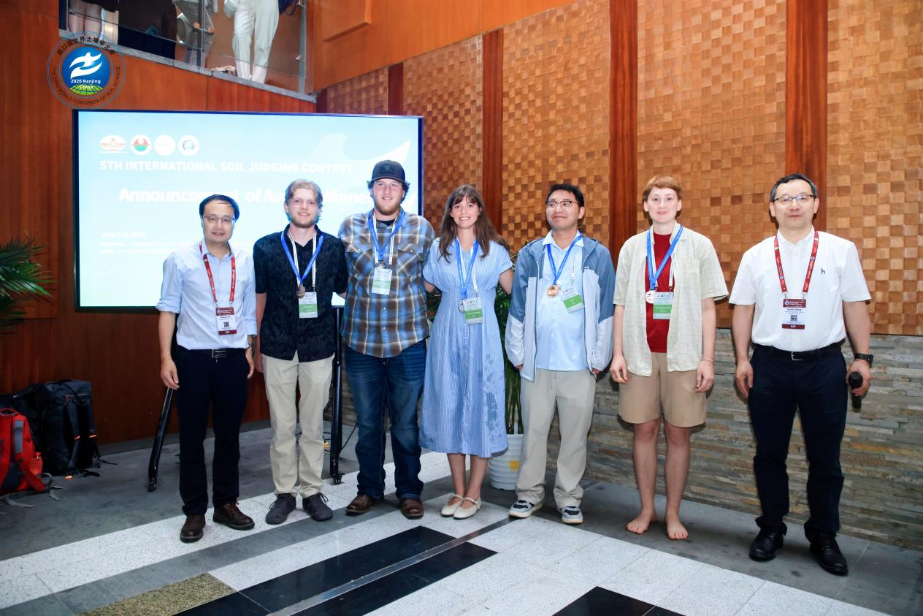

Throughout the event, the organizing committee demonstrated meticulous organization and professional service, earning high praise from all participants and stakeholders. Contestants and coaches from different countries exchanged knowledge and experience, deepening their understanding of soil classification and field profile interpretation. The organizers stated that this international competition has successfully established a premier global platform for soil science exchange, facilitated the cross-border connectivity of soil science education and research resources, and significantly advanced the training of soil science professionals as well as international cooperation in the discipline.
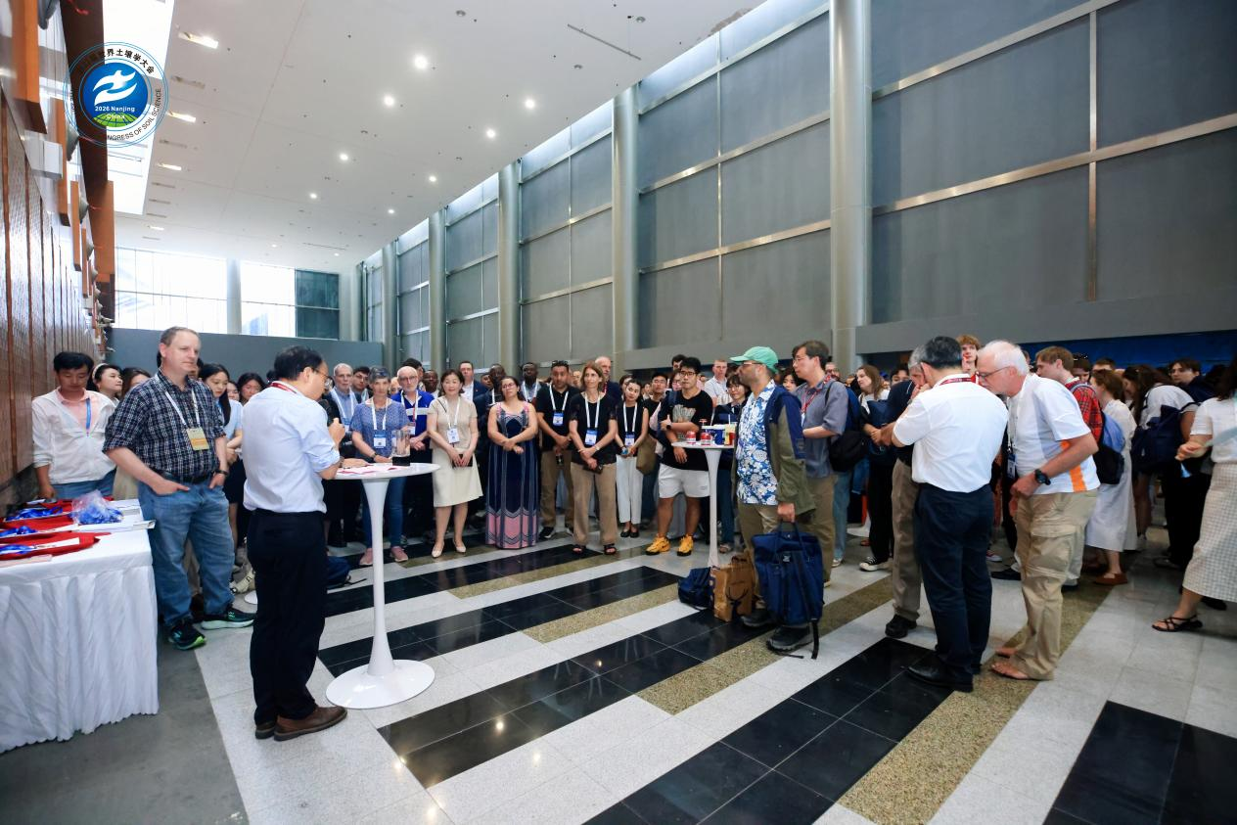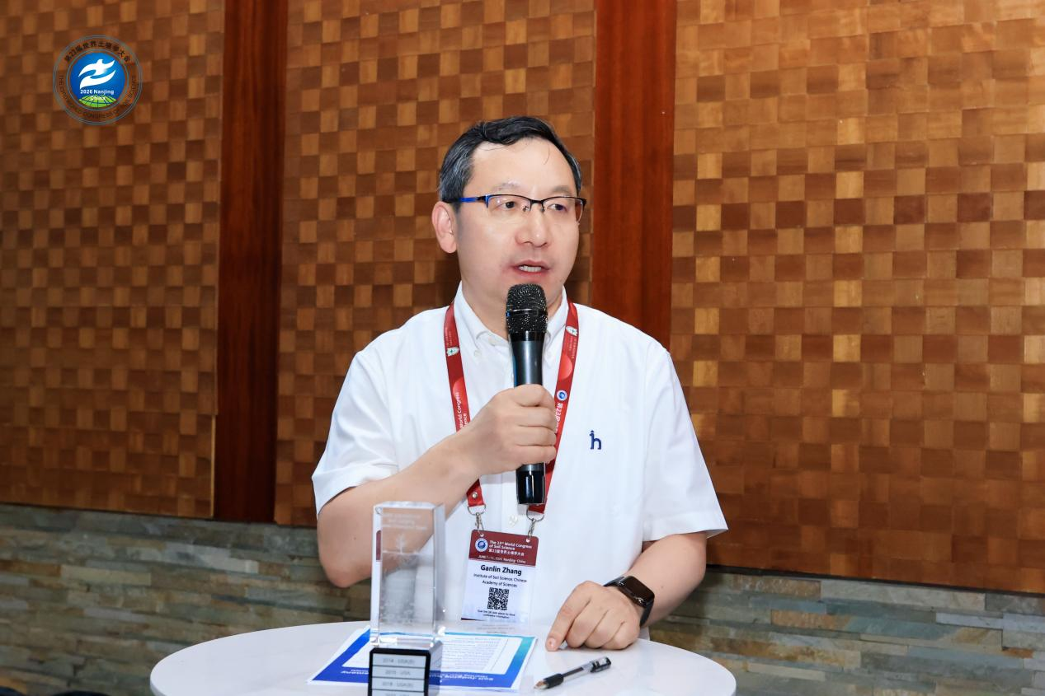
(Photo gallery:on-site scenes)
