Guidelines for Presentation File Preparation and Slide Testing for 23rd World Congress of Soil Science
Dear presenters,
Thank you for preparing your presentation for the academic program of the 23rd World Congress of Soil Science. To ensure that your presentation runs smoothly and that the on-site session proceeds in an orderly manner, please carefully read and follow the guidelines below when preparing your presentation file and completing the on-site slide testing process.
I. Requirements for Presentation Files
1. File Format
The Congress accepts presentation files in the following formats (the slide template is attached to this email):
- Standard Microsoft PowerPoint format, preferably .pptx;
- PDF format.
Other file formats are not supported by the on-site presentation system. To avoid any issues during your presentation, please make sure your file format meets the above requirements in advance.
2. Video Playback
During the presentation, the on-site system only supports playback of standalone PowerPoint or PDF files. It does not support external links that redirect to browsers, webpages, online video platforms, or other independent media players.
If your presentation includes video content, please embed the video into your PowerPoint file in advance and play it using PowerPoint’s built-in video controls.
The slide Management system supports the following video playback methods:
- Videos embedded directly in the PowerPoint file;
- Local video files linked within the PowerPoint file.
We recommend using common mainstream video formats such as MP4 or WMV. If you are unsure whether your video format is supported, please visit the Slide Collection Room as early as possible, where professional on-site staff will assist you with testing and troubleshooting.
3. Presenter View
The on-site presentation system does not support PowerPoint Presenter View.
During your presentation, the display on the computer and the projection screen will be the same. If you need speaker notes, prompts, or a presentation script, please print a hard copy in advance and bring it with you.
4. Aspect Ratio
All session rooms are equipped with display and projection devices using a 16:9 aspect ratio. Please prepare your presentation file in 16:9 format whenever possible.
If your file is prepared in another aspect ratio, black bars may appear on the sides or at the top and bottom during playback. However, the content will not be stretched or distorted.
II. How to Bring Your Presentation File
After preparing your final presentation file, please save and bring it to the venue using one or more of the following methods:
- USB flash drive, portable hard drive, or other storage device;
- Cloud storage download;
- Email attachment or downloadable link.
We recommend preparing at least one backup method in case of file damage, device recognition issues, or unstable network access.
III. Slide Testing and Upload Requirements
The Congress will use a unified slide Management system to manage all presentation files. To ensure smooth playback, please make sure to arrive at the Slide Collection Room corresponding to your session room area at least 2 hours before your scheduled presentation to complete file upload and playback testing.
Please check the exact time, session room, and area of your presentation in advance. Then, according to the official room-area layout map provided by the Congress, proceed to the corresponding Slide Collection Room.
The venue is divided into two session room areas, and each area will have one Slide Collection Room. Please go to the Slide Collection Room assigned to the area where your session room is located, so as to avoid delays caused by going to the wrong area.
Speaker Slide Collection Room 1, 3rd Floor, Nanjing International Expo Conference Center
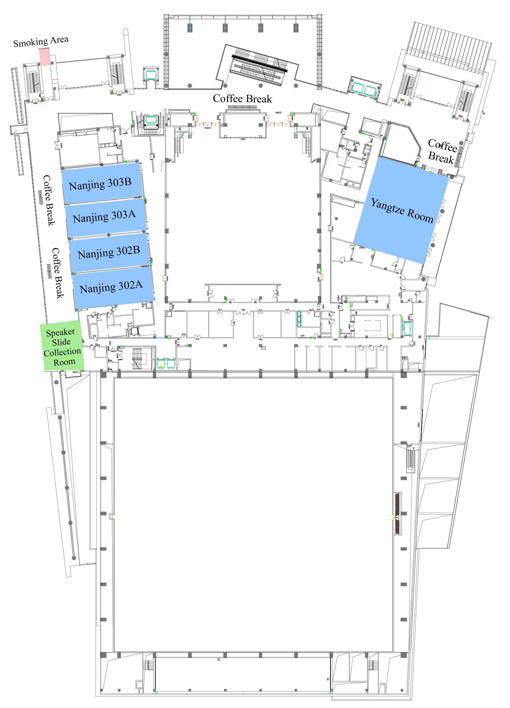
Speaker Slide Collection Room 2, Lobby 1st Floor, Hall 5, Nanjing International Expo Center
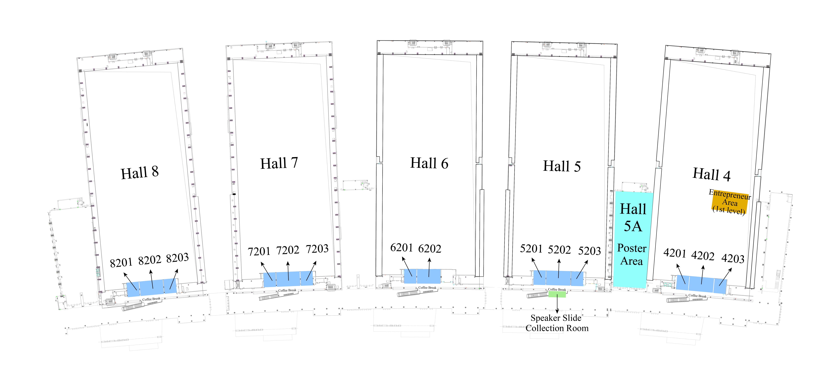
IV. Helpful Reminders
To ensure a smooth presentation, we kindly recommend that you:
- Check in advance that your PowerPoint or PDF file can be opened properly;
- Complete slide testing in advance if your file contains special fonts, animations, videos, or audio;
- Make sure any embedded videos can play properly within PowerPoint;
- Bring both your final presentation file and a backup copy;
- Allow sufficient time to visit the Slide Collection Room and avoid last-minute queues before your presentation.
Thank you for your support and cooperation.
Welcome to the beautiful city of Nanjing, China. We wish you a successful presentation and an enjoyable experience at the 23rd World Congress of Soil Science.
Organizing Committee of the 23rd World Congress of Soil Science
May 26, 2026

