Introduction of Soil Carbon Neutrality and Climate Change Response Experimental Platform
The increase in atmospheric carbon dioxide concentration ([CO₂]) and rising temperatures are key characteristics of global climate change, directly impacting sustainable human development. Ecosystems, particularly agriculture, face immense pressure in adapting to these changes. Therefore, how to adapting to climate change is one of humanity's greatest challenges.
This project, led by the Institute of Soil Science, Chinese Academy of Sciences, with Nanjing agricultural university as a partner unit, will establish a fully functional, technologically advanced, and openly shared research platform in Chunhua, Nanjing, focusing on soil carbon neutrality and climate change adaptation research. By simulating climate scenarios with elevated [CO₂] and temperature increases, the project will investigate the responses of agricultural ecosystems and deep soil to climate change. Clarify the mechanisms of crop yield, quality, and soil elemental processes response to climate change.
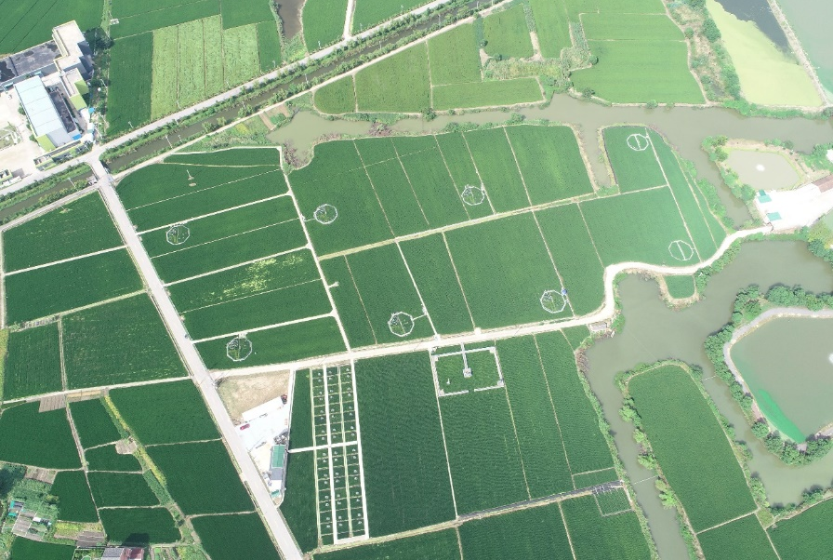
Fig 1 Overhead view of the facility

In order to achieve the above objectives, three facilities were established, these were:
1. Surface Climate Change Simulation System
2. Deep Soil Ecosystem Simulation System
3. Farmland Carbon Sequestration and Emission Reduction Technology Development Platform
These facilities provide research support for disciplines such as crop science, soil science, plant nutrition, ecology, and environmental science.
- Surface Climate Change Simulation System
Main Objective: Develop a Free-Air [CO₂] Enrichment couple with whole-ecosystem warming (air + water + soil temperature) to accurately simulate future climate scenarios.
Under global climate change scenarios, the increase in [CO₂] and temperature rise often occur simultaneously. Compared to single-factor scenarios, the interaction of dual factors better reflects the real situation of global change.
This system has constructed the world's first Free-Air CO₂ Enrichment couple with whole-ecosystem warming facility (T-FACE) for rice-wheat rotation systems (Figure 2). It can simultaneously simulate elevated [CO₂], canopy temperature and soil-water temperature rise under open-air conditions. The system achieves a control accuracy of over 90% for 87% of the operating time, significantly outperforming other similar systems (Table 1).
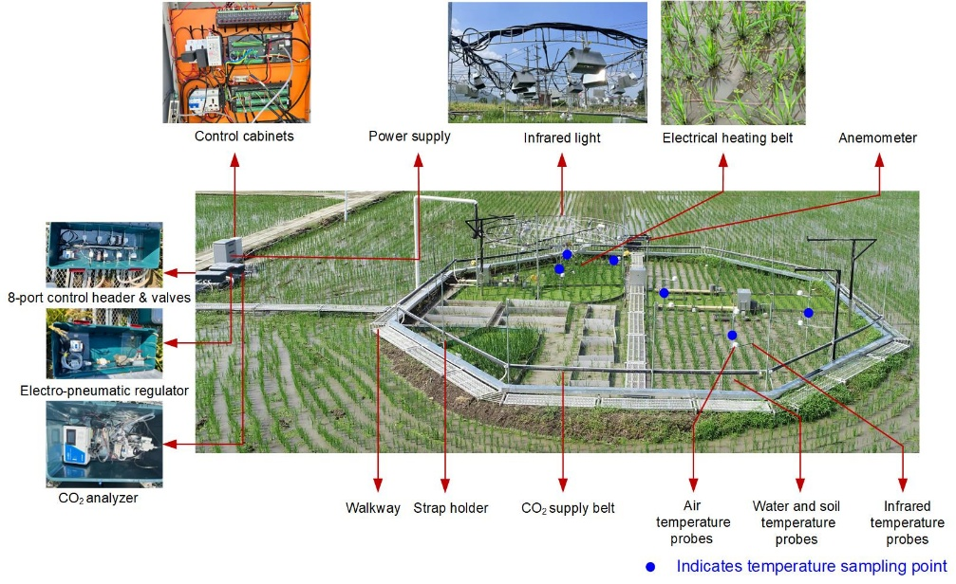
Fig 2 Schematic diagram of the T-FACE
Table 1 Summary of global large- FACE. The site, diameter, [CO₂] performance and source of each FACE are reported. The 1-min [CO₂] are chosen to calculate deviation from target [CO₂]
Site | within±20% of target [CO₂] | within±10% of  target [CO₂] | Source
Orange County, N.C. USA | 92% | 69% | Hendrey et al., 1999
Tuscania, Italy | 91% | 75% | Miglietta et al., 2001
Shizukuishi, Japan | 91% | 68% | Okada et al., 2001
Horsham, Australia | No data | 79% | Mollah et al. 2011
Iwate, Japan | 91% | 68% | Tokida et al., 2010
Tsukubamirai, Japan | 91% | 74% | Nakamura et al., 2012
Jiangdu，China | 90% | 80% | Zhu et al., 2018
Nanjing, China | 96% | 84% | Present facility

The canopy warming system employs a high-strength steel double-layer circular frame for hanging infrared lamps. By reducing the power of single infrared lamp while increasing their quantity and optimizing their layout, the shading rate has been minimized to 2.45% (Figure 2).
The lamp frame can be freely adjustable in height, therefore the distance between the infrared lamps and the canopy can be controlled at the centimeter level, significantly reducing energy consumption, meanwhile ensuring more uniform warming.
The system maintains infrared temperature within ±0.5°C of the target values for 89% of the operating time, outperforming similar facilities. And water and soil temperatures remain within ±0.5°C of the target values for 92% of the time (Table 2). The spatial variation in infrared temperature across the warming zone is only 10.2%, demonstrating high uniformity (Figure 3).

Table 2 Summary of global free-air warming facility
Location | Proportion of time  in canopy temperature rise |  |  | Proportion of time  in water/soil temperature rise |  | Reference
Location | Target±0.5℃ | Target±0.2℃ |  | Target±0.5℃ | Target±0.2℃ | Reference
Dan yang, China | 67% | No data |  | - | - | Rehmani et al., 2011
Illinois, USA | 83% | 35% |  | - | - | Kumagai et al., 2021
Wyoming, USA | 75% | 43% |  | - | - | Kimball et al., 2008
Haibei,China | 70% | 40% |  | - | - | Kimball et al., 2008
Changshu,China | No data | No data |  | - | - | Cai et al. 2016
Nanjing,China | 89% | 57% |  | 92% | 78% | Present facility
"-", means the facility lacks water/soil temperature rise function.

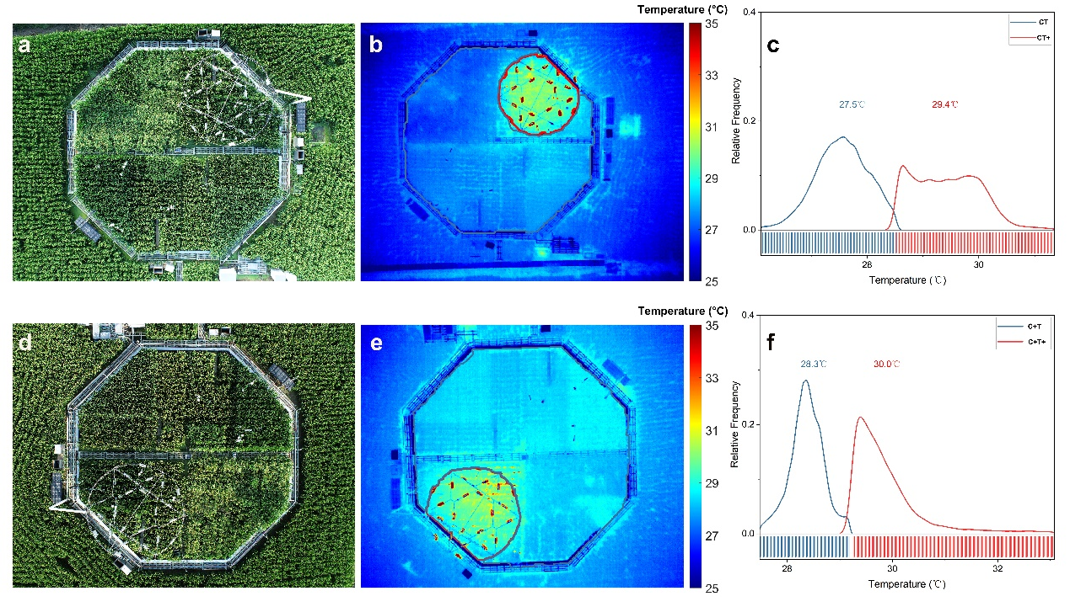
Fig 3 Aerial view of ambient and infrared warming zone and spatial distribution of temperature

- Deep Soil Ecosystem Simulation System
Main Objective: Establish an in-situ deep soil column coupled with an open-top chamber (OTC) for climate change simulation to study the response of deep soil layers to climate change.
This platform will establish an open-top chamber (OTC) system in the field capable of real-time control of atmospheric [CO₂], air temperature, and soil temperature across the 0-1m profile, enabling precise simulation of multiple climate scenarios.
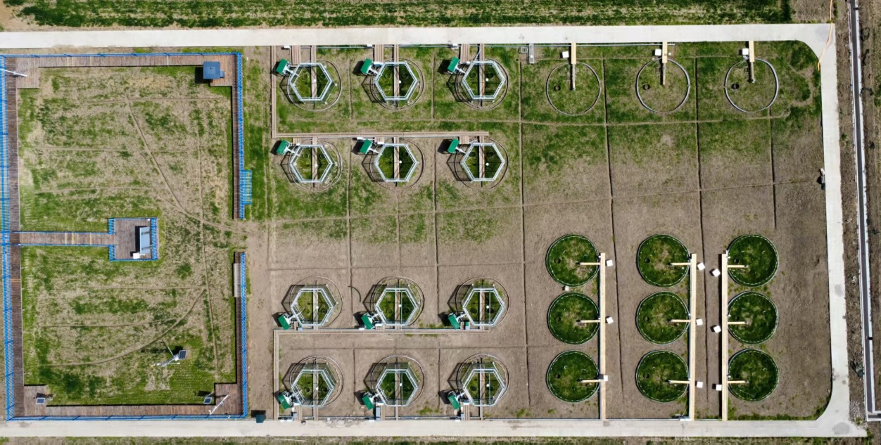
Fig 4 Deep soil ecosystem simulation system
Researchers can utilize this platform to:
1、Investigate the response of soil carbon and nitrogen processes across the entire soil profile to different climate change scenarios.
2、Develop synergistic technologies for soil carbon sequestration, emission reduction, and yield enhancement under future climate conditions.

- Farmland Carbon Sequestration and Emission Reduction Technology Development Platform
Main Objective: Establish an automated monitoring system for farmland soil environmental factors and greenhouse gas emissions, and develop low-carbon agricultural technology models.
This platform primarily focuses on the development and integration of soil carbon sequestration and greenhouse gas emission reduction technologies in agricultural under current climatic conditions. A total of 48 field plots, with various treatments, have been established, including：（1）Different water management regimes；（2）Various fertilizer types；（3）Multiple rice cultivars. To obtain long-term soil database, each plot equipped with an automated greenhouse gas flux observation system, a real-time soil temperature and moisture monitoring system, and an automatic irrigation system. The automated greenhouse gas flux observation system enables simultaneous measurement the greenhouse gas flux of all 48 experimental plots, with each sampling channel operating independently without interference. Thus, the experimental errors arising from asynchronous sampling coupled with significant diurnal flux variations in agricultural systems can be eliminated. Furthermore, the system allows user-defined adjustments to sampling parameters (intervals, channels, sequence), enabling adaptation to either intensive diurnal measurements or prolonged multi-region surveillance.
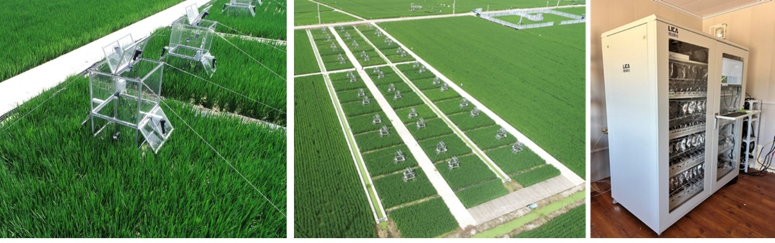
Fig 5 Synchronized automated observation system for greenhouse gas fluxes

4．The operation system for all the facilities
To enhance the control of the aforementioned platform, we have developed an automated control system that enables real-time monitoring of all equipment statuses and operational parameters. The system can automatically activate or deactivate based on predefined conditions, achieving unmanned, intelligent operation (Figure 6).
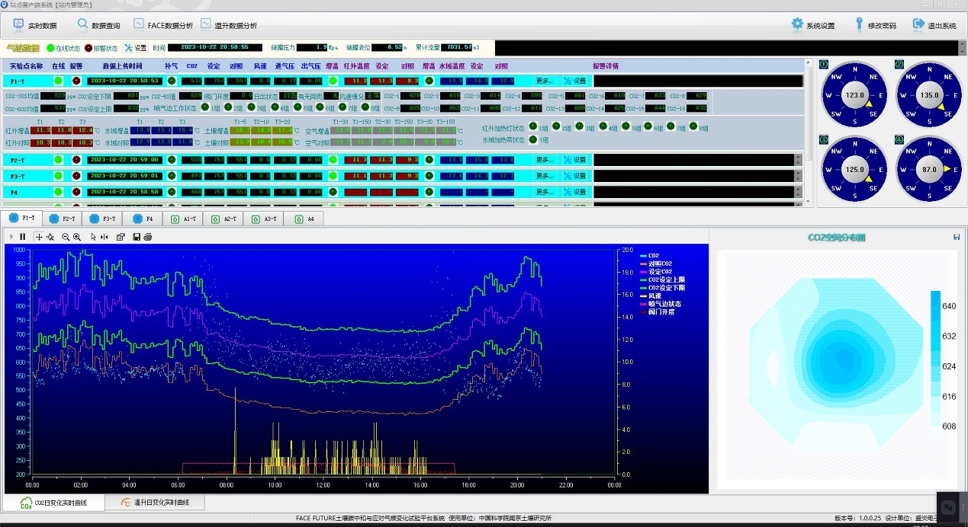
Fig 6 Automated Control System
Each facility integrates real-time 24/7 monitoring, threshold-triggered alarms, and automated circuit diagnostics to mitigate risks like intrusion, hardware failures, or electrical faults. This ensures operational continuity and maintains globally unmatched control accuracy.

